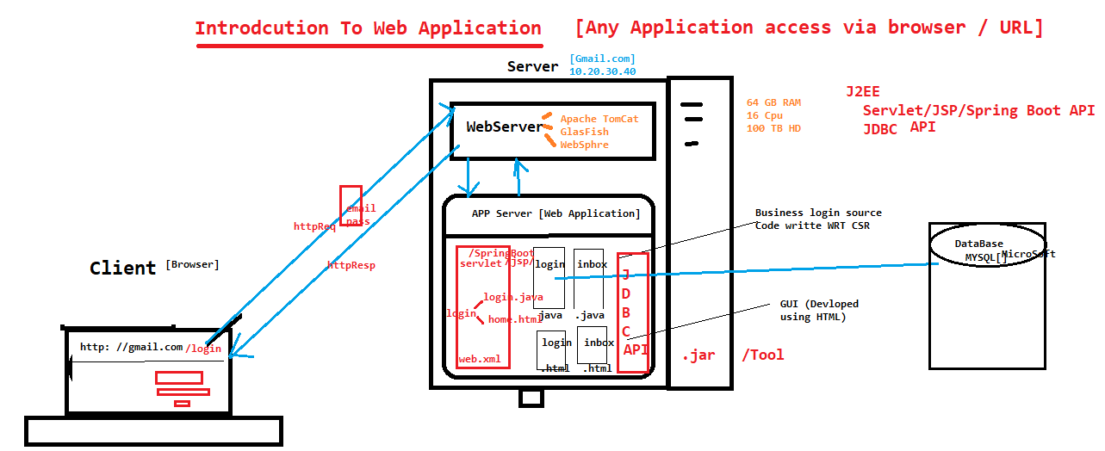

**Web Browser**

* **It is a standalone application which is used to access any web application over the network via URL**
* **Browser understands and interpret only html so that it always create http request and interpret httpresponse given by web server**
* **It’s one & only way to access web application**
* **Browser always send / receive request via http Protocol**

**EG :**

**chrome, IE , safari , firefox, Uc , opera etc**

**Http Protocol: it’s a set of instruction or rules, & it’s communication media between browser & webserver , http protocol by default understand html language**

**Web Server:**

* **Like any other application (Adobe Reader, Media Player, etc.,) , Webserver is also an application which runs on Operating System, & every AppServer(webApplication) is under control of Webserver**
* **Webserver as the name implies “Serves requests to a Browser, it helps both web browser & webApplication to interact with each other**
* **It always receive the request from the browser & talk to web application & provide response back to browser**

**Few Examples:**

* **Apache Tomcat**
* **Apache JBOSS**
* **IBM WebSphere**
* **Oracle WebLogic**
* **JBOSS**
* **Oracle GlassFish & many more…**

**App Server / Web Application:**

* **Collection of web Resources present inside webApplcation called AppServer**
* **AppServer contains business logic of the source code , & html code , Servlet Code , JDBC code**
* **Web Resource are always implemented using Servlet or JSP or SpringNBoot for JAVA , ASP.net for C#**

**Web Resource: where business logic code is written**

**Two types of WebResource**

**1 . Static WebResource : response present inside the webApplication before the request**

**Wikki pedia**

**Documentation WebSite**

**Note: to develop static WebApplication only HTML is enough**

**When web plication is a collection of static webResource is called static web Application**

**2. Dynamic WebResource: response getting generated at the time of request**

**EG :**

**internetBanking**

**vodofona bill**

**gmail**

**When webAplication contains at least one dynamic webResource is called Dynamic web Application**

**Note: servlet or JSP or Spring boot is mandate to develop dynamic Web application**

**Data Base**

* **It also an application which helps us to store the data in the form of table**

**Example :**

* + **MySql**
  + **MsQsl**
  + **Oracle 10 g**
  + **DB2**
  + **Mongo DB**
  + **NoSql**
  + **Sybase**

**JDBC API :**

* **It is collection API , which is used to connect to data base from the java Program**
* **Using JDBC, we can store & fetch the data from the database**

**EG:**

**mysql-jdbc-connector.jar**

**Ojdbc.jar**

**Db2-jbdv.jar**

**Servlet :**

* **Servlet is a collection J2ee API , used Its used to develop dynamic webApplication**
* **Servlet also contains web.xml file , which is used for mapping between java & html file**

**What technology your Application Built on ?**

**Front end : html-5 or Anguler-JS or React JS**

**BackEnd : java + (SpringBoot or Servlet or JSP)**

**DataBase : Mysql or Oracle-11g or DB2 or MONGO db**

**What is URL ?**

**Unified resource location: used to identify specific webresourse inside the webapplication, URL is one & only way to accesses any webapplication vai browser**